|  |  |  |  |  |  |  |  |  |  |  |  |
| --- | --- | --- | --- | --- | --- | --- | --- | --- | --- | --- | --- |
|  | | **Hope Foundation’s,**  **Finolex Academy of Management and Technology, Ratnagiri** | | | | | | | | | |
| **Department of Information Technology** | | | | | | | | | |
| Subject name: SECURITY LAB | | | | | | | | Subject Code: ITL502 | | | |
| Class | | TE IT | | Semester – V (CBCGS) | | | | Academic year: 2018-19 | | | |
| Name of Student | | Kazi Jawwad A Rahim | | | | | **QUIZ Score : 05** | | | | |
| Roll No | | 32 | | | Experiment No. | | | | | 06 | |
| Title**.**  **Study the use of network reconnaissance tools like WHOIS, dig,traceroute, nslookup to gather information about networks and domain registrars.** | | | | | | | | | | | |
|  | | | | | | | | | | | |
| **Course objectives applicable:**   * To know how to gather information about the networks by using different n/w reconnaissance tools. | | | | | | | | | | | |
| **Course outcomes applicable:**   * Understand, identify, analyze and design the problem, implement the same using current techniques, skills, and tools and validate the solution including both hardware and software. | | | | | | | | | | | |
| **Learning Objectives:**   * Use network-based tools for network analysis. | | | | | | | | | | | |
| **Hardware Requirements**:   1. PC with 4GB RAM, 500GB HDD.   **Software Requirements:** WHOIS client | | | | | | | | | | | |
|  | | | | | | | | | | | |
| **Quiz Questions (if any): (Online Exam will be taken separately batchwise, attach the certificate/ Marks obtained)**   * How to use traceroute to identify network problem? * What is "WHOIS" database? * Which command is used for verifying and troubleshooting problems? * How to Use Nslookup to Verify DNS Configuration? | | | | | | | | | | | |
|  | | | | | | | | | | | |
| **Experiment/Assignment Evaluation:** | | | | | | | | | | | |
| **Sr. No.** | **Parameters** | | | | | | | | **Marks obtained** | | **Out of** |
| **1** | Technical Understanding (Assessment may be done based on Q & A **or** any other relevant method.) Teacher should mention the other method used - | | | | | | | |  | | 6 |
| **2** | Neatness/presentation | | | | | | | |  | | 2 |
| **3** | Punctuality | | | | | | | |  | | 2 |
| **Date of performance (DOP)** | | |  | | | **Total marks obtained** | | |  | | **10** |
| **Date of checking (DOC)** | | |  | | | **Signature of teacher** | | | | | |

**Output:**

**1)Dig :**

**Command : dig domain_name**

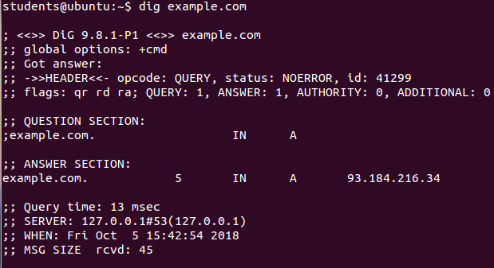

**2)Nslookup:**

**Command : nslookup domain_name**

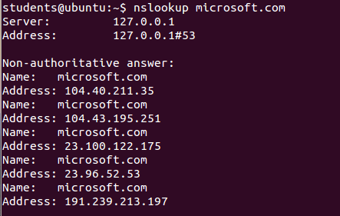

**3)traceroute:**

**Command : traceroute domain_name**

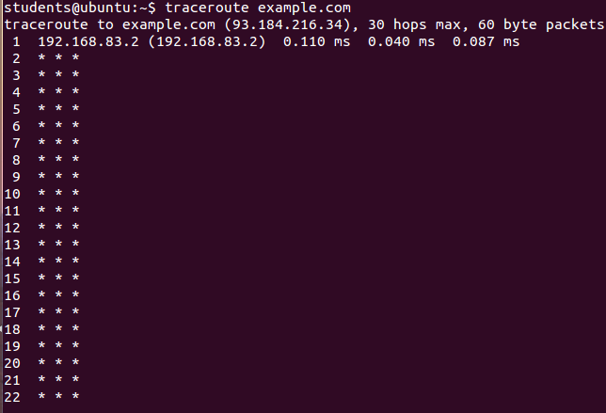

**References** :

* http://www.howtogeek.com/134132/how-to-use-traceroute-to-identify-network-problems/
* http://www.networksolutions.com/whois/index.jsp?bookmarked=84d1182fe7fc4eaf63cca54a21b1:9jF4